ARYAMAN MISHRA

19BCE1027

**Program for DDA Line Drawing Algorithm in C**

#include<stdio.h>

#include<stdlib.h>

#include<graphics.h>

#include<math.h>

void LineDDA(int x0,int y0,int x1, int y1)

{

double xIncrement,yIncrement,x,y;

int dx = x1 - x0,dy = y1-y0,steps,i;

if(abs(dx)>abs(dy)) steps = abs(dx);

else steps = abs(dy);

//one of these will be 1 or -1

xIncrement = (double)dx/(double)steps;

yIncrement = (double)dy/(double)steps;

x = x0;

y = y0;

putpixel((int)x,(int)y,WHITE);

for(i = 0;i < steps; i++)

{

x+=xIncrement;

y+=yIncrement;

putpixel((int)x,(int)y,WHITE);

}

}

void main()

{

int gd = DETECT,gm;

int x0 = 100,y0 = 100;

int x1 = 400,y1 = 400;

initgraph(&gd,&gm,"c:\\turboc3\\bgi");

clrscr();

LineDDA(x0,y0,x1,y1);

getch();

closegraph();

}

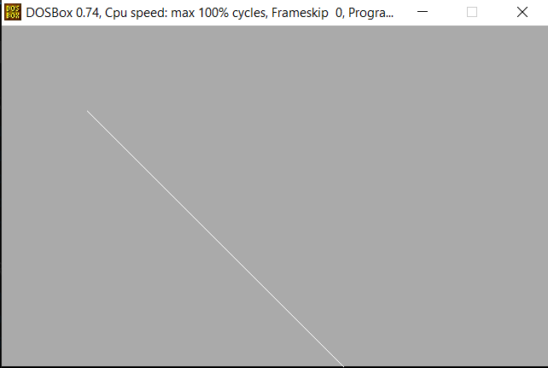

## Program for Bresenham's Line Algorithm

## Algorithm in C

## #include<stdio.h>

## #include<stdlib.h>

## #include<graphics.h>

## #include<math.h>

## #include<conio.h>

## void LineBres(int x0,int y0,int x1,int y1)

## {

## int dx=abs(x1-x0),dy=abs(y1-y0);

## int d=2*dy-dx,twoDy=2*dy,twoDyMinusDx=2*(dy-dx);

## int x,y;

## if(x0>x1)

## {

## x=x1;

## y=y1;

## x1=x0;

## }

## else

## {

## x=x0;

## y=y0;

## }

## putpixel((int)x,(int)y,RED);

## while(x<x1)

## {

## x++;

## if(d<0)d+=twoDy;

## else

## {

## y++;

## d+=twoDyMinusDx;

## }

## putpixel((int)x,(int)y,RED);

## }

## }

## void main()

## {

## int gd = DETECT,gm;

## int x0 = 220,y0 = 220;

## int x1 = 380,y1 = 380;

## initgraph(&gd,&gm,"C:\\TURBOC3\\BGI");

## clrscr();

## LineBres(x0,y0,x1,y1);

## getch();

## closegraph();

## }

